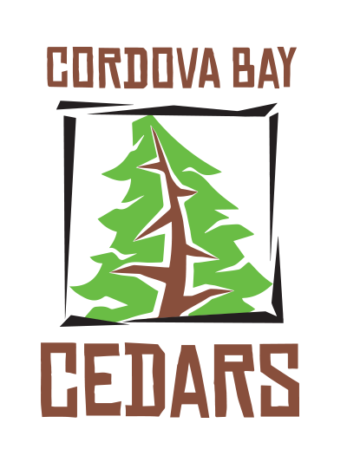

2020-2021 CORDOVA BAY PAC
ELECTRONIC COMMUNICATION CONSENT FORM
( Please fill out One Form per FAMILY )

What is the Cordova Bay Parent Advisory Council (PAC)?
Cordova Bay PAC is a volunteer organization comprised of parent volunteers. The purpose of the PAC is to aid our school community with support for educational and recreational needs; and to encourage Cordova Bay school spirit.

How does the PAC communicate with families?
The majority of communication is by monthly emails that may include newsletters, reminders, sign-up forums or announcements. The Class Representatives (volunteers for each classroom) will also email families on classroom/school happenings. Additionally, PAC News can be read in the School’s Weekly Emailed Communications.

In order to communicate these happenings to families, we require each year “consent” from parents/caregivers agreeing to be on the PAC communication email list. Being part of these communications ensures you will be informed about what is going on.

If you consent to receive email communications from PAC/Classroom Representatives, please fill in the information below. Emails remain confidential and will only be used to communicate PAC/School Information.

(Fill in Form Electronically OR Print, Fill Out and Return to your child’s teacher)

__CHILD’S NAME , GRADE , TEACHER NAME(s) (ie. Sally French, 3, Mrs. Lovely) _

2.

3.

(1) Parent/Guardian Name:

Email (print clearly):

(2) Parent/Guardian Name:

Email (print clearly):

Please return via Email to: cordovabaypac@gmail.com
OR
Hardcopy to your child’s teacher

